THE UNIVERSITY OF BUEA

P.O Box 63,

Buea,South West Region

Cameroon

Tel: (237) 674354327

Fax: (237) 3332 22 72

**FACULTY OF ENGINEERING AND TECHNOLOGY**

**DEPARTMENT :Computer Engineering**

**COURSE CODE : EEF460**

**COURSE TITLE:INTERNET AND MOBILE PROGRAMMIN**



**REPUBLIC OF CAMEROON**

PEACE-WORK-FATHERLAND

**DESIGN AND IMPLEMENTATION OF A MOBILE-BASED ARCHIVAL AND RETRIEVAL OF MISSING OBJECTS USING IMAGE MATCHING**

**PRESENTED BY**

|  |  |  |
| --- | --- | --- |
| **NAME** |  | **MATRICULE** |
| EKUNDIME GLEAN MAKOGE | FE21A433 |  |
| DJOUMESSI LEKANE WENDY FORTUNE | FE21A173 |  |
| INDAH RISCOBELLE MBAH | FE21A204 |  |
| KEDJU PRECIOUS NGWE LEKUNZE | FE21A211 |  |
| NGUEDIA JEATSA JOYCE GRACE | FE21A263 |  |

**Course Supervisor Dr NKAMENI VALERY**

**Academic year: 2023/2024**

Table of Contents

1. **Introduction…………………………………………………………………………3**

## Overview of FindAM

## Purpose of the Report

1. **Project Background…………………………………………………………………3**
   1. Problem Statement
   2. Objectives
   3. Scope
2. **Technology Stack……………………………………………………………………5**
   1. Overview of Technologies Used
   2. Justification for Using React Native
   3. Color Scheme: Orange and White
3. **Design and Development Process…………………………………………………..7**
4. **Implementation………………………………………………………………………9**
5. **Features and Functionality………………………………………………………….12**
6. **Conclusion……………………………………………………………………………13**
7. **References…………………………………………………………………………….14**
8. **Introduction**
   1. **Overview of FindAM**

The loss or misplacement of personal belongings is a common and often distressing experience. Traditional methods, such as posting flyers or contacting lost and found services, are frequently time-consuming and ineffective. To address this issue, **FindAM** aims to develop a mobile application leveraging image matching algorithms and mobile technology to create a robust and user-friendly platform for archiving and retrieving missing objects.

## **Purpose of the Report**

The purpose of the design and implementation of FindAM is to create a user-friendly mobile application that leverages advanced image matching algorithms and mobile technology to streamline the process of finding lost and missing objects. By providing a centralized platform for users to upload images of lost items and search for potential matches, the app aims to reduce the inconvenience and distress associated with lost belongings. The application will also foster community engagement and collaboration in the search process, making it easier and more efficient to recover lost items.

1. **Project statement**

#### **2.1 Problem Statement**

Creating a user-friendly and intuitive user interface (UI) for the FindAM mobile application presents several challenges. The UI must be easy to navigate, visually appealing, and efficient in guiding users through the processes of uploading images of lost items and searching for potential matches. Additionally, the design must accommodate diverse user needs and preferences, ensuring accessibility and inclusivity.

**2.2. Objectives**

* **Intuitive Navigation**:

Design a straightforward and seamless navigation system that allows users to easily access different features of the app.

* **Visual Appeal**:

Create an attractive UI that uses a consistent color scheme and typography to enhance user engagement.

* **Ease of Use**:

Ensure that all interface elements are easy to use and understand, minimizing the learning curve for new users.

* **Accessibility**:

Implement design principles that cater to users with different abilities, ensuring the app is accessible to all.

* **Responsive Design**:

Ensure the UI is responsive and functions well across various devices and screen sizes.

* 1. **Scope**
* **Wireframing and Prototyping**
* **Wireframes**:

Create low-fidelity wireframes to outline the basic structure and layout of the application’s screens.

* **High-Fidelity Prototypes**:

Develop high-fidelity interactive prototypes in Figma to visualize the final design and flow.

* **User Testing**:

Conduct usability testing sessions with potential users to gather feedback on the wireframes and prototypes, making necessary adjustments based on the feedback.

* **User Interface (UI) Design**
* **Color Scheme**:

Use an orange and white color scheme to create a vibrant and engaging interface. Orange is chosen for its energy and attention-grabbing properties, while white provides a clean and uncluttered background.

* **Typography**:

Select readable and modern fonts to ensure that all text elements are easy to read and visually appealing.

* **Icons and Imagery**:

Use clear and meaningful icons and imagery to support navigation and provide visual cues.

* **Layout**:

Design intuitive layouts that prioritize important information and actions, ensuring that users can easily find what they need.

* **Component Design**
* **Reusable Components**:

Develop reusable UI components (e.g., buttons, input fields, cards) to maintain consistency across the app.

* **Interactive Elements**:

Ensure that interactive elements provide clear feedback, such as visual changes on tap or click, to improve user interaction.

* **Implementation with React Native**
* **Development Environment Setup**:

Set up the development environment using React Native for cross-platform compatibility.

* **Component Structure**:

Design a modular component-based architecture to ensure maintainability and scalability.

* **Styling**:

Use styling libraries such as Styled Components or React Native’s StyleSheet to implement the UI design.

* **State Management**:

Implement state management using Redux or React’s Context API to handle UI state efficiently.

1. **Technology Stack**

**3.1. Overview of Technologies Used**

* **React Native**:

A JavaScript framework for building natively rendered mobile applications for iOS and Android.

* **Redux**:

A state management tool used to manage and centralize application state.

* **Figma**:

A design tool used for creating wireframes, prototypes, and high-fidelity UI designs.

* **Node.js**:

A JavaScript runtime used for building the backend server and RESTful APIs.

**3.1. React Native** was chosen for the development of FindAM for several key reasons:

* **Cross-Platform Compatibility**:

React Native allows the development of applications for both iOS and Android platforms from a single codebase, significantly reducing development time and effort.

* **Performance**:

React Native uses native components, which ensures high performance and a smooth user experience compared to traditional hybrid apps.

* 1. **Orange and White were chosen as the primary colors for the FindAM app for the following reasons**:
* **Psychological Impact**:
  + **Orange**: Often associated with energy, enthusiasm, and attention. It's a color that can stimulate action and draw attention, making it suitable for an app focused on finding and archiving objects.
  + **White**: Represents simplicity, clarity, and ease of use. It provides a clean background that ensures content is easily readable and reduces visual clutter.
* **Brand Identity**:
  + The combination of orange and white creates a vibrant and modern look that can help the app stand out in the competitive market.
  + This color scheme aligns with the goal of creating an engaging and user-friendly application.
* **Accessibility**:
  + Orange and white offer high contrast, improving readability and usability for users with visual impairments.
  + Ensures compliance with accessibility standards, making the app usable for a broader audience.

1. **Design and Development Process**

**Overview:**

* **Figma**:

A collaborative web-based design tool used for creating wireframes, prototypes, and high-fidelity UI designs.

**Process:**

* **Wireframing:**
  + **Low-Fidelity Wireframes**: Basic sketches outlining the structure and layout of the app's screens.
  + **Purpose**: Focus on functionality and user flow without the distraction of design elements.
  + **Iterative Design**: Quickly iterate on ideas to identify the most effective layouts and interactions.

After properly studying the user requirements that what users want and need , we design the above prototype;

* **Section 1 : AUTHENTICATION**

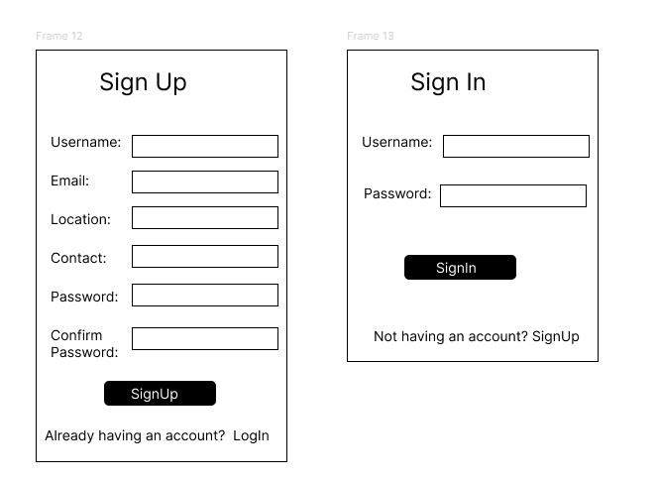

* 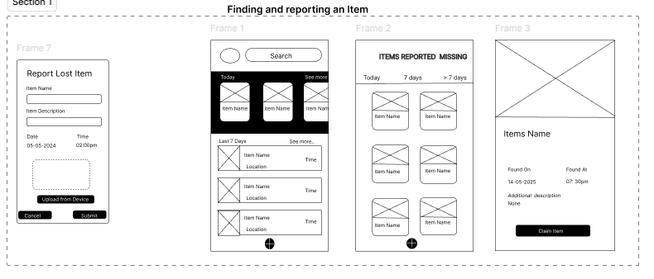**Section 2 : Finding and reporting an item**

**Section 3: Transaction after image matching**

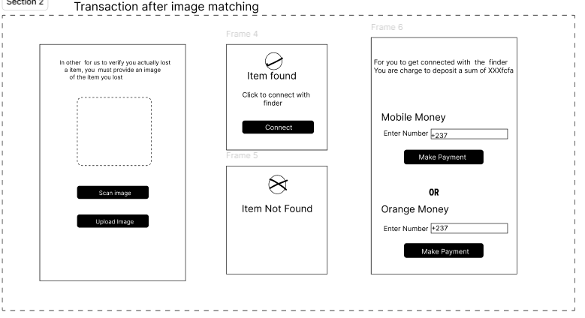

**Section 4 : Claimer connecting with finder**

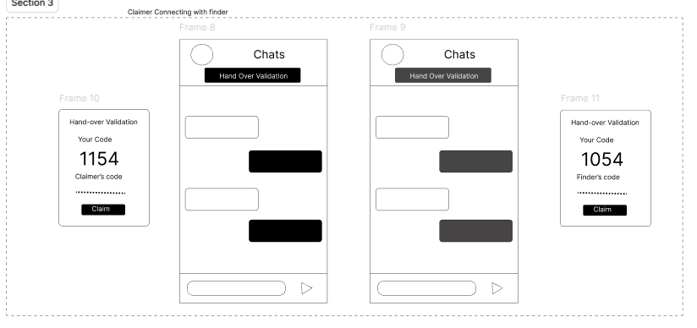

1. **Implementation of FindAM**

The implementation of the FindAM mobile application was carried out using React Native, a powerful framework for building cross-platform mobile apps.

Here we have the implementation of FindAM;

* **Section 1 : AUTHENTICATION**

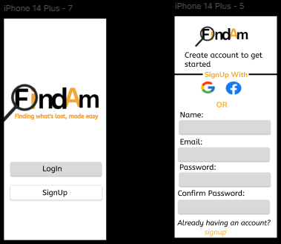

* **Section 2 : Finding and reporting an item**

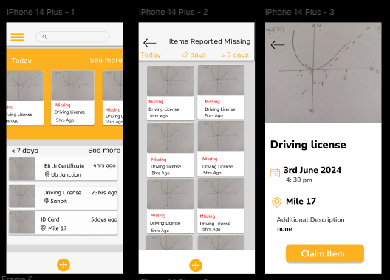

**Section 3: Transaction after image matching**

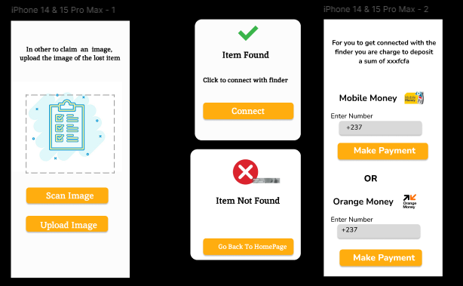

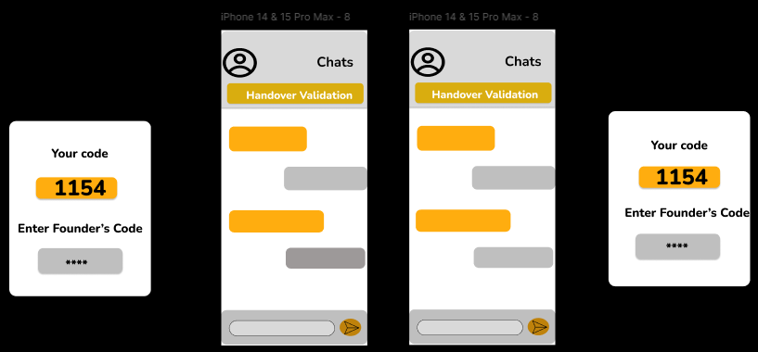**Section 4 : Claimer connecting with finder**

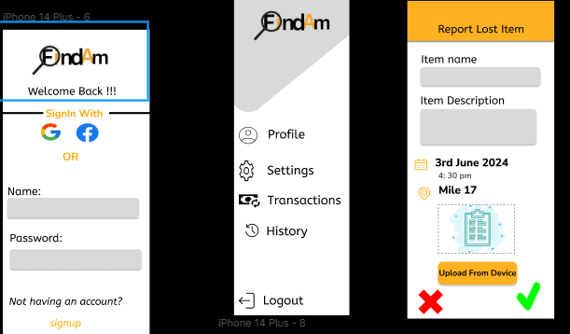**Other pages**

#### **Features and Functionality**

* **User Authentication**: Secure login and registration processes using JWT (JSON Web Tokens).
* **Image Upload and Retrieval**: Users can upload images of lost items, which are stored and indexed in the database.
* **Real-Time Image Matching**: Advanced image matching algorithms to compare uploaded images with archived objects.
* **Notifications**: Push notifications and email alerts to inform users of potential matches.
* **Social Sharing**: Integration with social media platforms to share lost item information and enlist community help.

1. **Conclusion**

By integrating these features and employing a well-thought-out design and implementation strategy, FindAM has proven to be an effective solution for the archival and retrieval of missing objects. This project not only enhances user convenience but also leverages community support, making the process of finding lost items more efficient and less stressful. The success of FindAM demonstrates the potential of mobile technology to solve everyday problems, paving the way for future innovations in this field.

1. **References**

React Native Official Documentation

<https://www.nativewind.dev/quick-starts/expo>

<https://docs.expo.dev/>

<https://reactnative.dev/>